**USER GUIDE FOR**

**LA IMPERIAL WEBSITE**

1. **System Requirement**

|  |  |  |
| --- | --- | --- |
| **No** | **Software** | **Description** |
| **1** | **Operating system** | **Windows 8 or higher** |
| **2** | **Hardware** | **Intel Pentium 4 processor or higher**  **512 Megabytes of RAM or higher** |
| **3** | **Software** | **Visual Studio Code, Dreamweaver** |
| **4** | **Web browser** | **Internet Explorer 11 , Chrome, Firefox** |

1. **Website installation**

- This document is created to guide users use the website – La Imperial effectively. It is advisable that users should read this document before starting to use this website in reality.

- To run *La Imperial* website, users can either follow these to options:

1. Access directly via our project github link:

<https://sc0ots.github.io/1910-eProject-Group_5/>

1. Download our project from github following these steps:
   * 1. Access our group project github repository address at:  
        [*https://github.com/sc0ots/1910-eProject-Group_5*](https://github.com/sc0ots/1910-eProject-Group_5)Under the Clone or download tab press Download as ZIP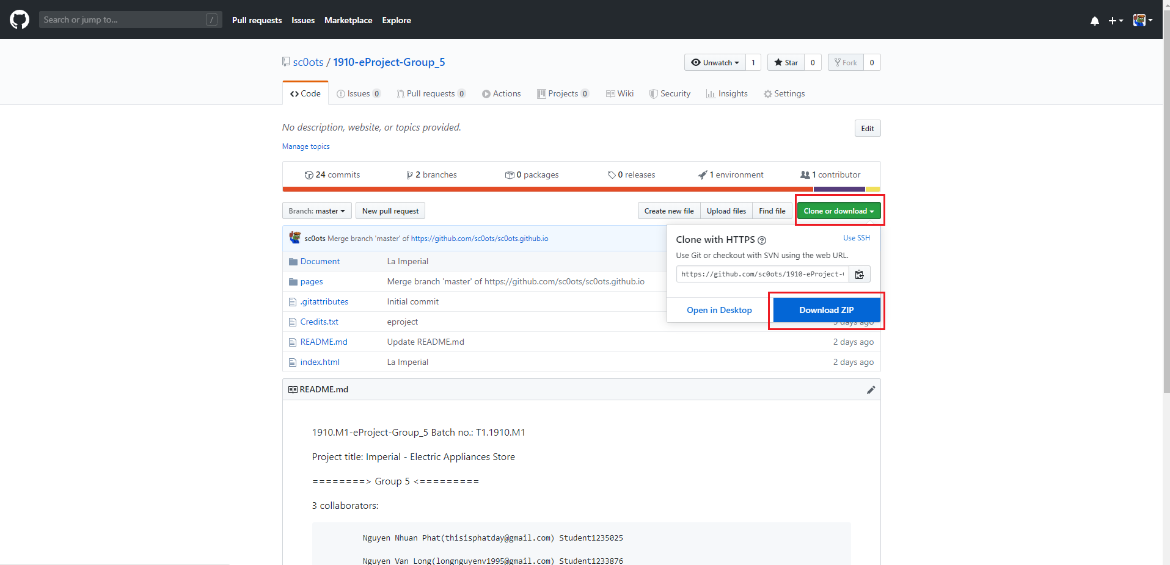
     2. Extract file rar: *eProject_LaImperial by Group_3 (FPT Aptech HCM)*
     3. Open folder *sc0ots.github.io.*
     4. Open *index.html* file to start the website.

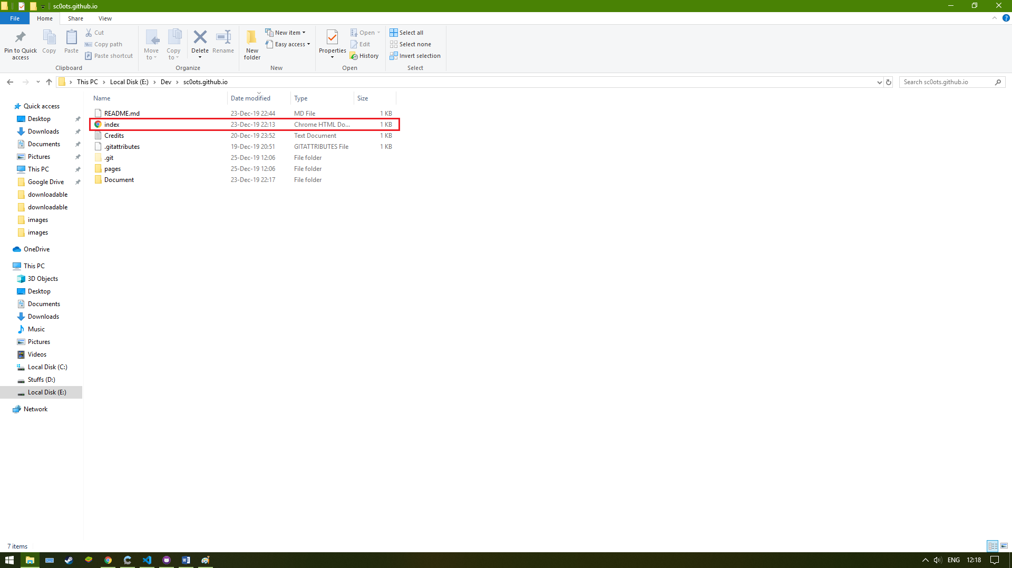

* + 1. If done successfully, users will see the Homepage like below:

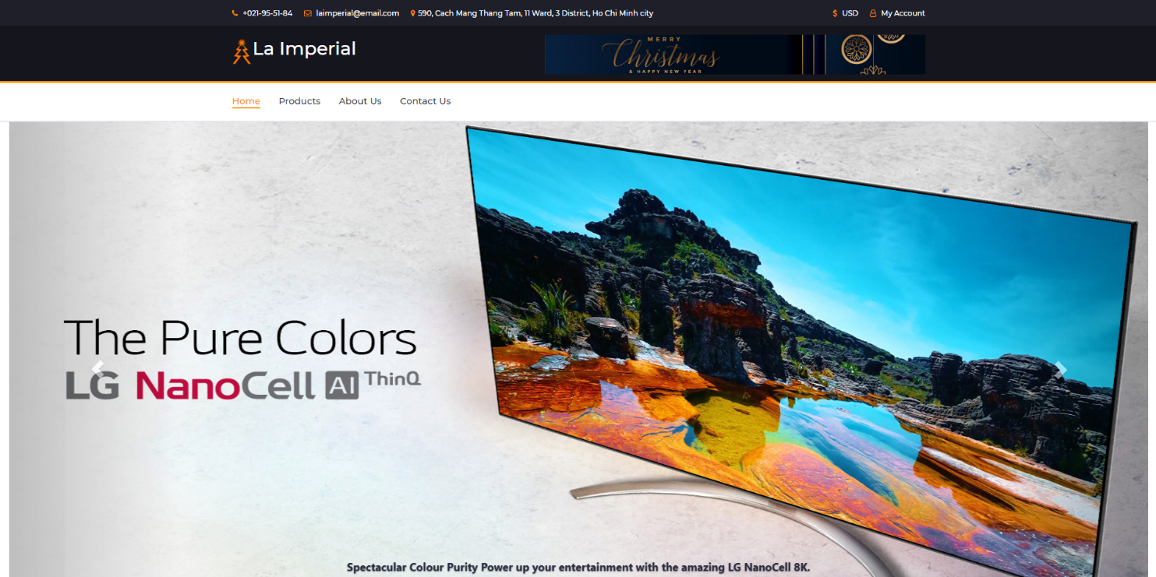

1. **Website Features Instructions**
2. **Navigation bar**

This component is the navigation bar for all the webpage section in the *La Imperial* website. To switch to other section, users simply need to click on a particular section. For example, picture below illustrates how to switch from Home section to Contact Us section.

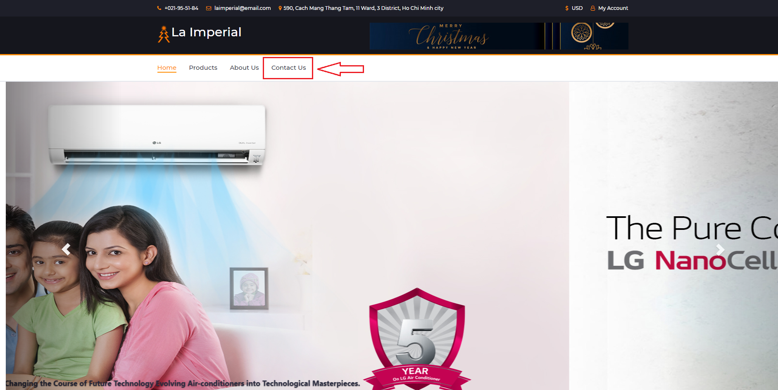

1. **Products Brand Viewing**

Users can choose to view certain brands of a product type by clicking the checkbox matching the brands users want to see.

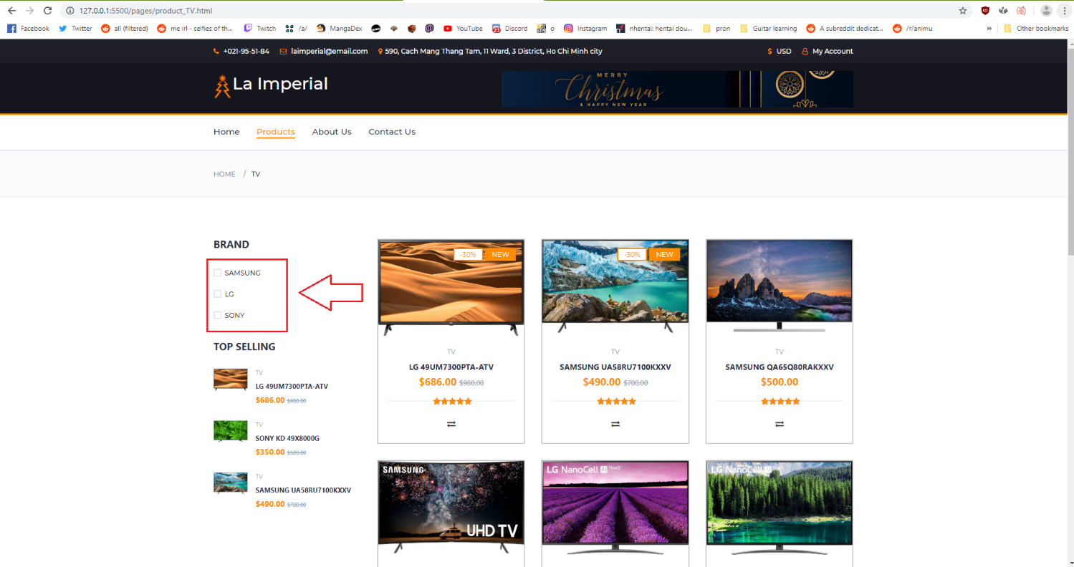

1. **Product comparing**

User can choose up to 3 product to compare by click the compare button on the product tab.

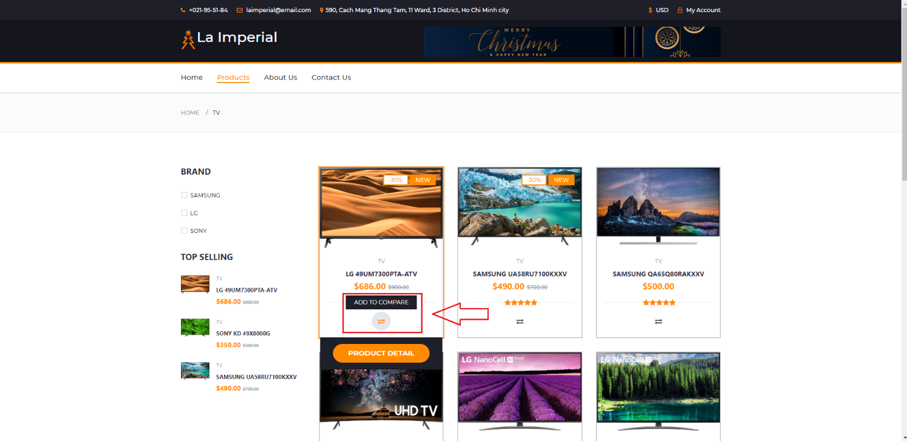

After clicking the compare button, a review panel will pop up showing the products that added to comparison. Click on the compare button to process to the compare panel.

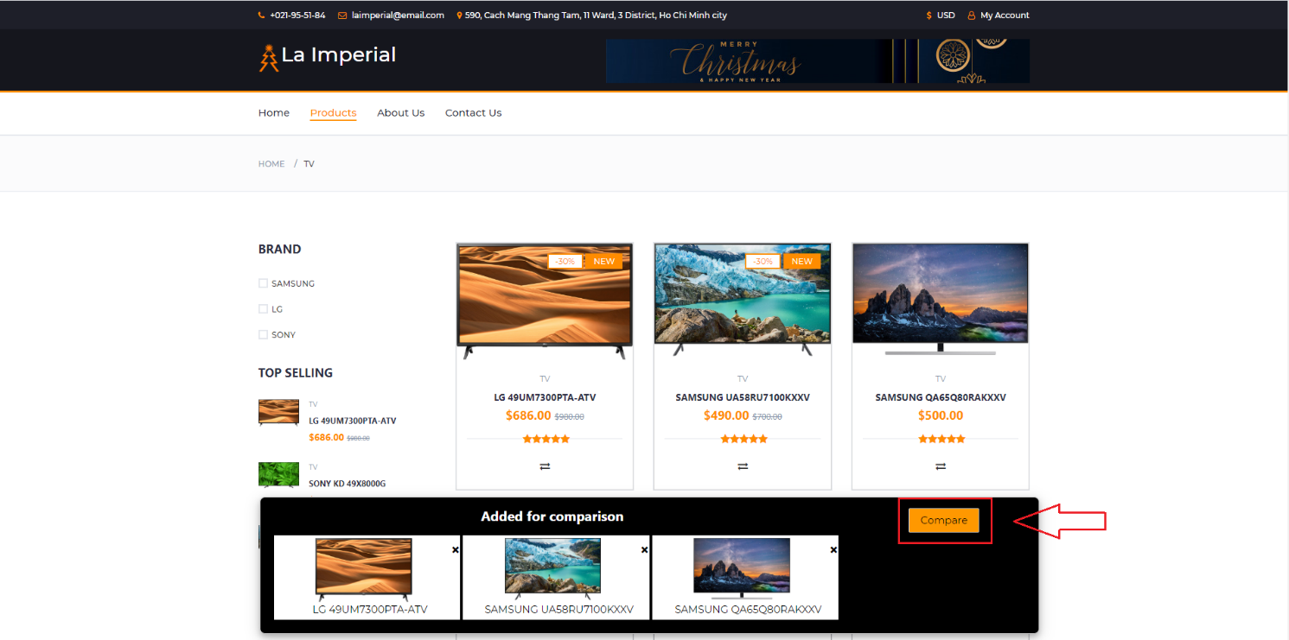

Click on the top right close button to close the compare panel.  
 